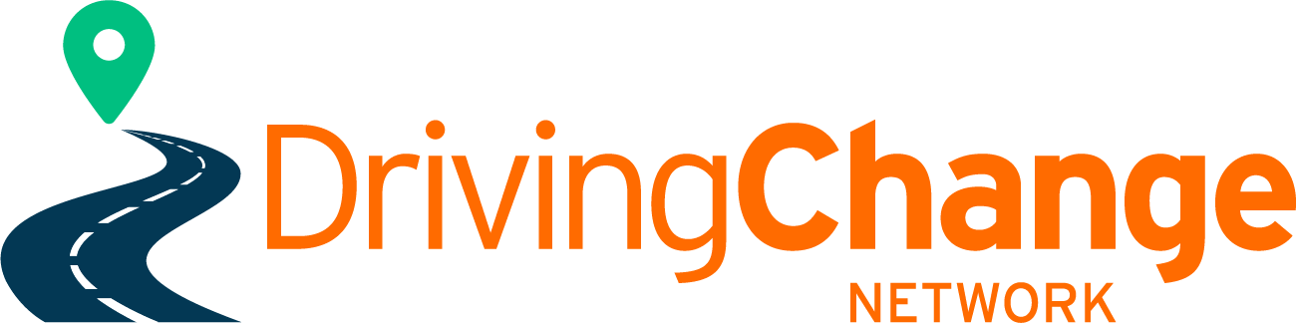
Feedback on Road to Zero Strategy
Focus Area 4: Road User Choices
Action
Increasing access to driver training and licensing.
“Early engagement to understand the barriers people face to getting a driver licence has shown that improved driver licence support and operational changes could make a big difference. Te Manatū Waka, Waka Kotahi and the Ministry of Social Development have been working together to support drivers to enter and progress through the licensing system to become safe and competent drivers. Funding has been made available from Budget 22 to target assistance for learners who are most disadvantaged in accessing driver licensing support. Some of this funding also supports improvements to the Waka Kotahi and ACC DRIVE programme that supports young drivers to learn to drive safely. Young drivers that have participated in the DRIVE education programme make approximately 40% fewer ACC claims than young drivers that have not participated. This is important as young drivers make up 13% of licensed drivers but are responsible for 30% of serious injury crashes and 26% of fatal crashes.

Waka Kotahi has also established a Driver Licensing Improvement Programme to improve access to the driver licensing system for those who want or need it. This programme will see Waka Kotahi take a leadership role in improving delivery and coordination across the driver licensing system with a strong focus on supporting people to access and progress through the licensing system.”
Extracts page 13 |  | Comments
“Early engagement to understand the barriers people face to getting a driver licence has shown that improved driver licence support and operational changes could make a big difference.” |  | Early engagement should be targeted at those just entering or about to enter the GDLS, which would mean greater support and focus to Secondary school students. This should be identified as a focus area within this focus area.
“Te Manatū Waka, Waka Kotahi and the Ministry of Social Development have been working together to support drivers to enter and progress through the licensing system to become safe and competent drivers” |  | The combined agency group should actively include the Ministry of Education given that the largest majority of drivers entering the licensing system are from Secondary schools.
“Funding has been made available from Budget 22 to target assistance for learners who are most disadvantaged in accessing driver licensing support. Some of this funding also supports improvements to the Waka Kotahi and ACC DRIVE programme that supports young drivers to learn to drive safely.” |  | Those most disadvantaged in accessing licensing support are often those that have no or limited access to the internet, data, and computers therefore ‘some’ funding should be supporting access to these tools c.  Investigate possibility of creating a new Student Loan criteria for those accessing Driver Education Programmes (subsidised model) in collaboration with RoVE initiative.
“Young drivers that have participated in the DRIVE education programme make approximately 40% fewer ACC claims than young drivers that have not participated. This is important as young drivers make up 13% of licensed drivers but are responsible for 30% of serious injury crashes and 26% of fatal crashes.” |  | Whilst we recognise this as an excellent educational tool and no doubt the improvement in accident statistics of those completing the programme, however, those ‘at risk’ and highlighted on page 1 of the ‘disproportionate harm’ to Māori is not reflected when measuring ‘best’ ways to increase access to driver licensing, via these statements.
Extract page 7 ‘Equitable Impacts’.
“We know from research undertaken through the first Road to Zero Action Plan that Māori experience disproportionate harm in the land transport system compared to non-Māori.4 The research points to important contextual considerations for Māori road safety outcomes, including geographical and age distribution and deprivation status of Māori. Addressing factors such as vehicle safety and occupant numbers, longer trips on higher risk remote rural roads, and systemic barriers to safe road use are likely to improve road safety outcomes for Māori.” |  | Community-centric driver programme providers, driving instructors and driving schools are critical to improve and achieve better outcomes for Māori, Pacifica, migrants, and other communities that have inequitable road safety outcomes due to their gender, ethnicity, income levels or location.
“Waka Kotahi has also established a Driver Licensing Improvement Programme to improve access to the driver licensing system for those who want or need it. This programme will see Waka Kotahi take a leadership role in improving delivery and coordination across the driver licensing system with a strong focus on supporting people to access and progress through the licensing system.” |  | There needs to be a commitment to Co-design vs consultation with field experts (ie: providers in communities) required when investigating system changes. The strategy is light in referencing the Government’s commitment to working with groups/organisations/providers who reach ‘those who want or need it’.
Extract page 26 “HOW WE WILL ACHIEVE IT” | LEAD AGENCY/AGENCIES |  | Comments
We will continue work to improve access to driver licensing and training to improve road safety outcomes through:
• improving access to driver licence support (including appropriate vehicles for learning to drive, driver training, and financial support for driver training or licence tests) for those who are most impacted by barriers to obtaining a driver licence | Ministry of Social Development |  | - We need to build in recognition of quality and quantity training support (to prevent 10-lesson packages).  - sustained quality learner-centric driver training and programmes  - Acknowledging the value of the critical contribution of volunteers by defining volunteer mentor recognition/reward/  - improved access for Māori, Pasifika and migrant groups  - To include as a lead agency Ministry of Education in this space.
• investigating and implementing operational and delivery improvements to the driver licensing testing system with a focus on improving access | Waka Kotahi |  | Including;  - multi-lingual access, (processes and testing)  - increased geographical access to testing  - investigate alternative solutions to improve testing times, eg contracted DI’s during peak periods and remote locations  - Investigating how to ensure all clauses referring to I-Endorsements are supporting (rather than hindering) Community Driver Training programmes being delivered.
• strengthening the requirement for approved courses that can reduce the time a person holds a restricted car licence before they can get a full licence, to ensure safety outcomes are improved for drivers participating in these courses | Waka Kotahi |  | - ‘Strengthening the training and requirement for approved…’, and  - improve the programmes focus and delivery with more practical participation and appropriate theoretical application for these courses.  To include Driving Instructors:  - support and strengthen instructor capacity and standards.  - To support multi-lingual / cultural individuals to access financial and training to be Driving Instructors. Therefore to strengthen the access for more diversity with DI’s.
• establishing ongoing monitoring of the driver licensing system to identify issues and gaps to access in a timely manner | Ministry of Social Development, Waka Kotahi and Te Manatū Waka Ministry of Transport |  | Monitoring and ‘consultation and co-design’ in a broader capacity, on a regular basis with more groups and providers operating in the DL space.

